Fidelis Kaloki Mwanzia
BSCCS/2024/32530
Computer Science
BIT 3208
Advanced Web Design and Development
Michael Nyoro
Year IV, Semester II

Project:
Gaming Supplies Ecommerce Website

Technologies Used:
Vue
MongoDB
Express
Node.js

Github Repo Link:
https://github.com/Kasankal/Advanced-Web.git

Contents
WEEK 1: Setup 4
MongoDB setup 4
Database Connected. 4
WEEK 2: Wireframes and Mockups. 5
2.1 Shopping cart wireframe. 5
2.2 Product page wireframe 6
2.3 Product Info wireframe. 7
2.4 Landing page mockup 7
2.5 Technologies used. 8
WEEK3: Form Validation. 9
3.1 Login and Register Form Mockups. 9
3.2 Database user model code snippet. 10
3.3 Login validation 11
WEEK4: Database and Form Validation. 12
4.1 Login Form screenshots 12
4.2 Login Validation Screenshot. 12
4.3 Folder Structure. 13
4.4 Database Connection. 14
4.5 Github Updated. 14
WEEK 5: Database and CRUD. 15
5.1 Database Screenshot. 15
5.2 Table Creation and CRUD Operations. 16

Figure 1: MongoDB setup 4
Figure 2: Database Connected successfully. 4
Figure 3: Shopping cart wireframe. 5
Figure 4:Product Page Wireframe 6
Figure 5: Language prediction code and output. 7
Figure 6:Landing page mock up. 7
Figure 7: Login Form 9
Figure 8: Register Form 9
Figure 9:Code snippet of the user model 10
Figure 10: Login validation Code Snippet 11
Figure 11: Login Form Screenshot 12
Figure 12: Login successful 12
Figure 13: File structure 13
Figure 14: Database Connected Successfully 14
Figure 15: Project pushed updates 14
Figure 16: Screenshot of the Database 15
Figure 17: User model created 16
Figure 18: Code Snippet of the user creation 17
Figure 19: Update 17

WEEK 1: Setup

MongoDB setup
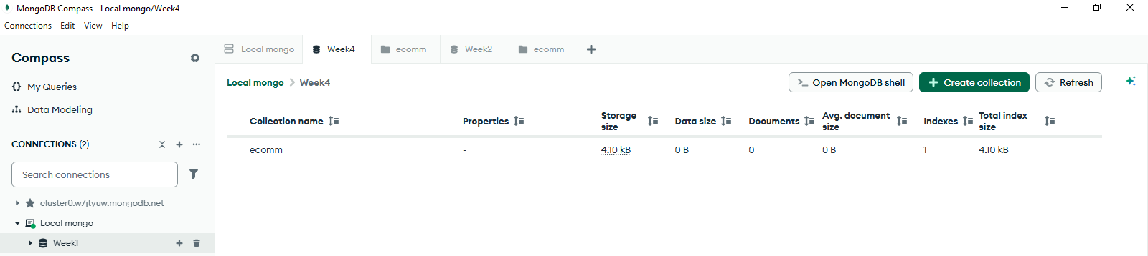
Figure 1: MongoDB setup
A local mongodb database.
Created collections with the naming scheme Week[number], to align with the versioning instructions.

Database Connected.
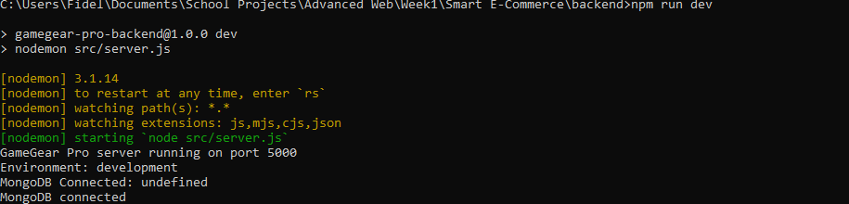
Figure 2: Database Connected successfully.
Figure 3: Weekly URI
I only have to change the last part depending on the database I want to connect to.

WEEK 2: Wireframes and Mockups.

2.1 Shopping cart wireframe.
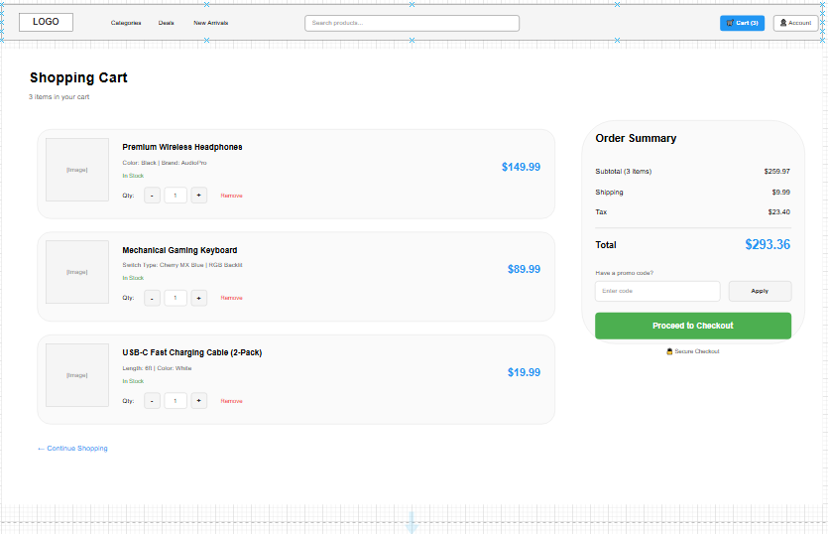
Figure 4: Shopping cart wireframe.

2.2 Product page wireframe
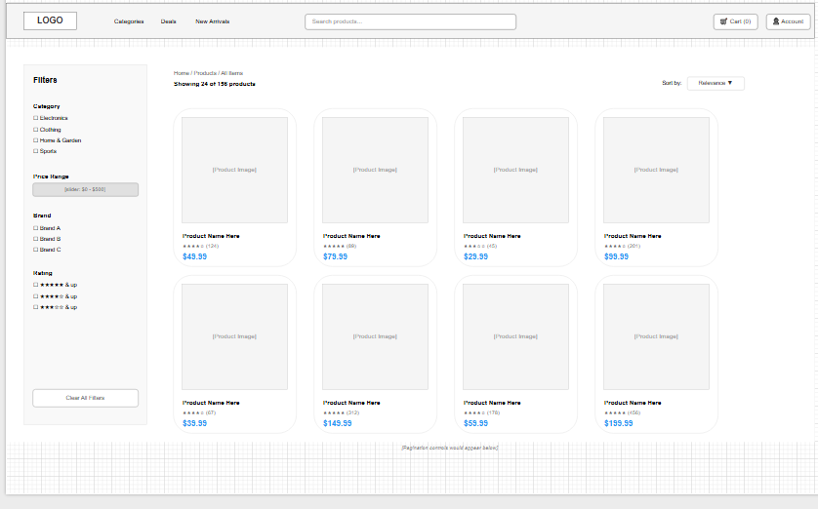
Figure 5:Product Page Wireframe

2.3 Product Info wireframe.
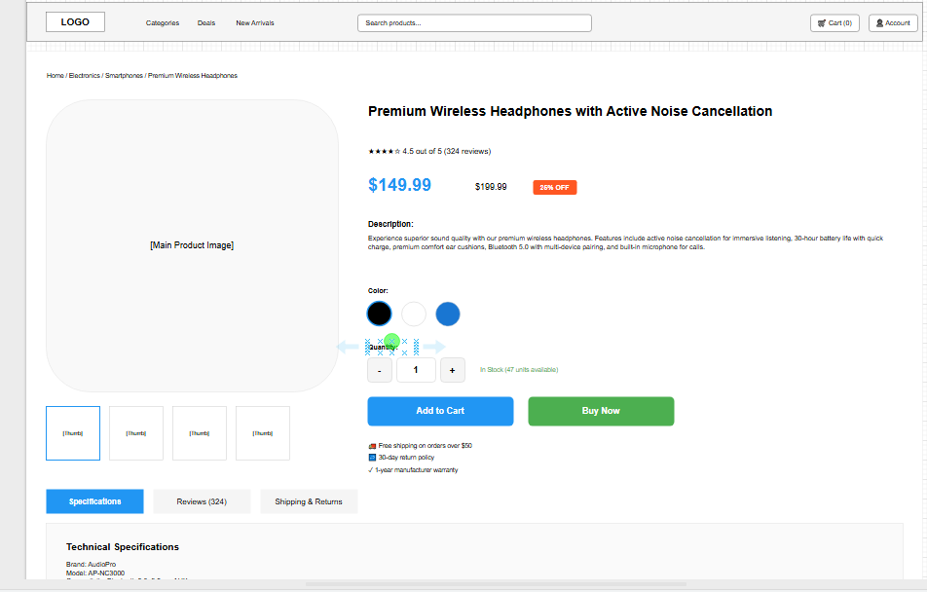
Figure 6: Language prediction code and output.

2.4 Landing page mockup
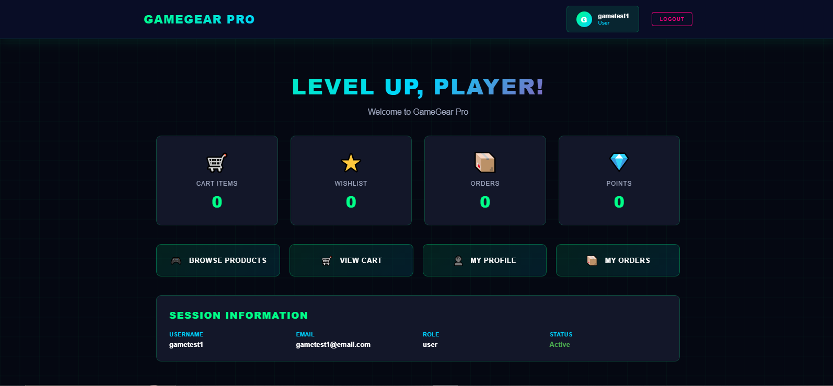
Figure 7:Landing page mock up.

2.5 Technologies used.

The Full tech stack consists of:
Vue, Express and MongoDB

WEEK3: Form Validation.

3.1 Login and Register Form Mockups.
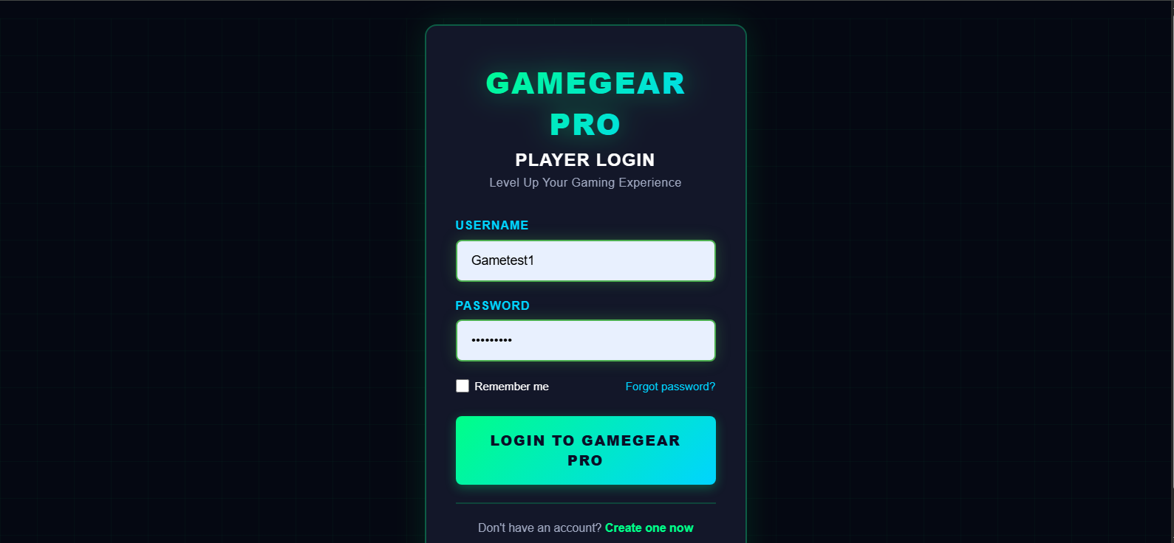
Figure 8: Login Form
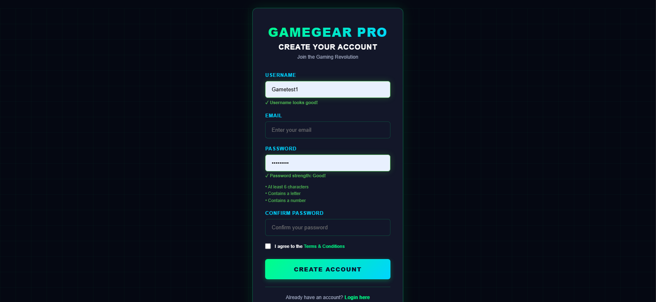
Figure 9: Register Form

3.2 Database user model code snippet.
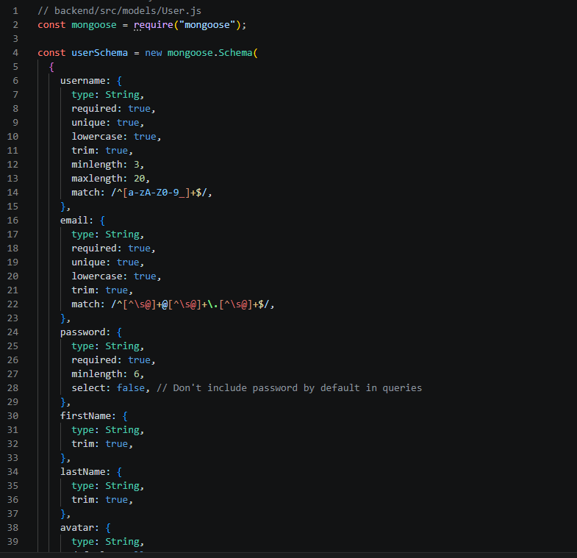
Figure 10:Code snippet of the user model

3.3 Login validation
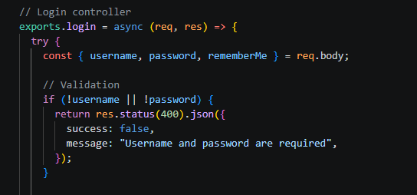
Figure 11: Login validation Code Snippet

WEEK4: Database and Form Validation.

4.1 Login Form screenshots

Figure 12: Login Form Screenshot

4.2 Login Validation Screenshot.
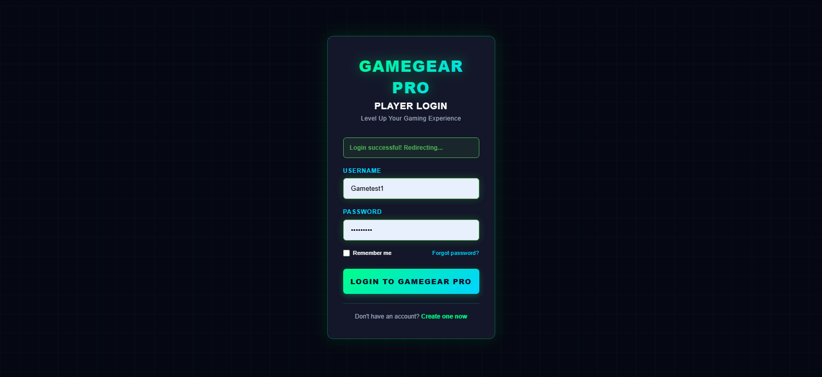
Figure 13: Login successful

4.3 Folder Structure.

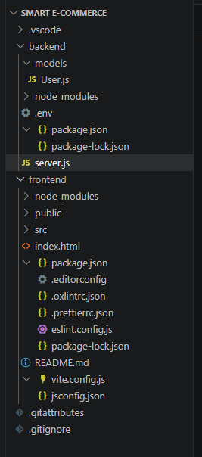
Figure 14: File structure
Frontend and Backend each have their own folders to make updates easier.

4.4 Database Connection.

Figure 15: Database Connected Successfully

4.5 Github Updated.
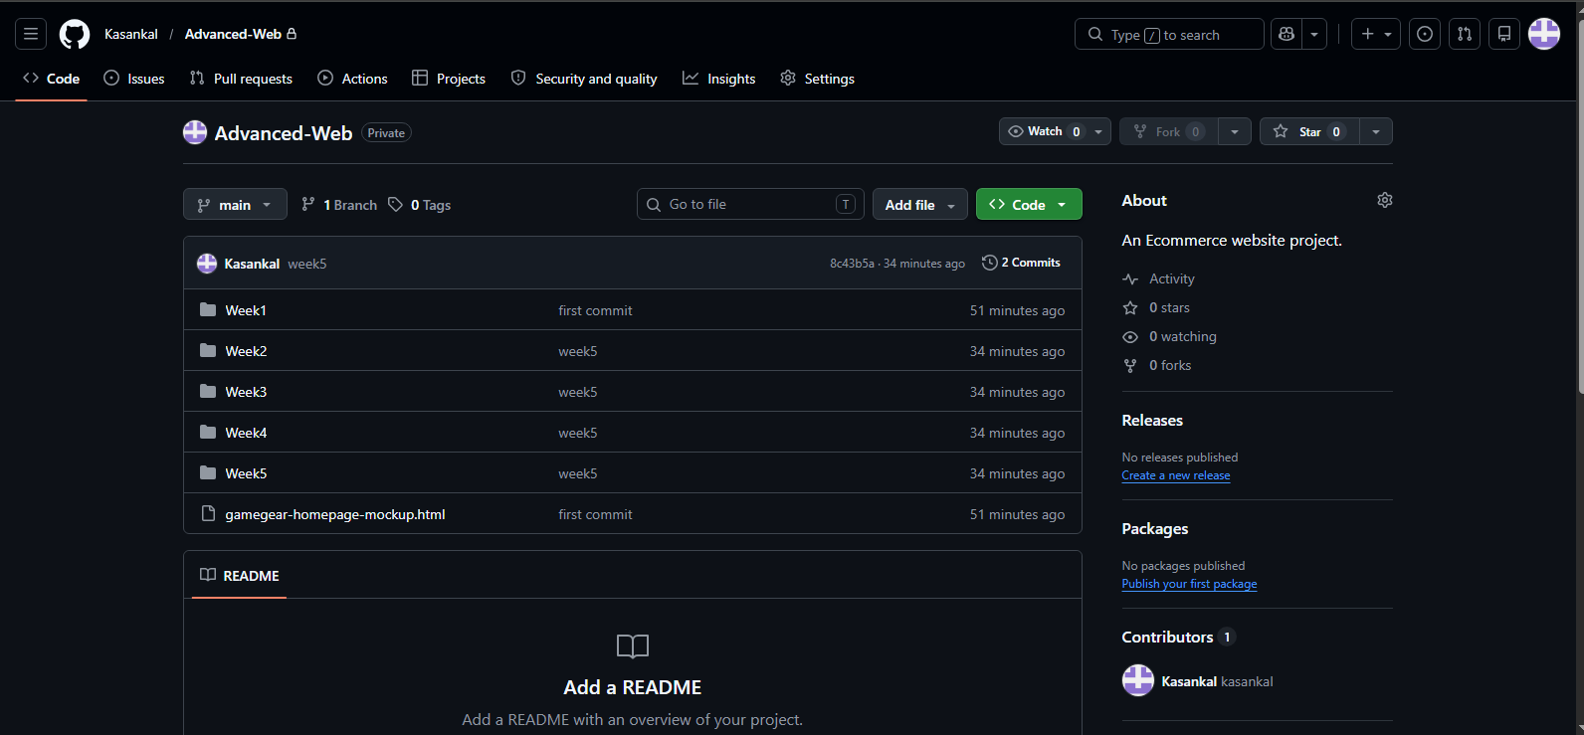
Figure 16: Project pushed updates

WEEK 5: Database and CRUD.

5.1 Database Screenshot.
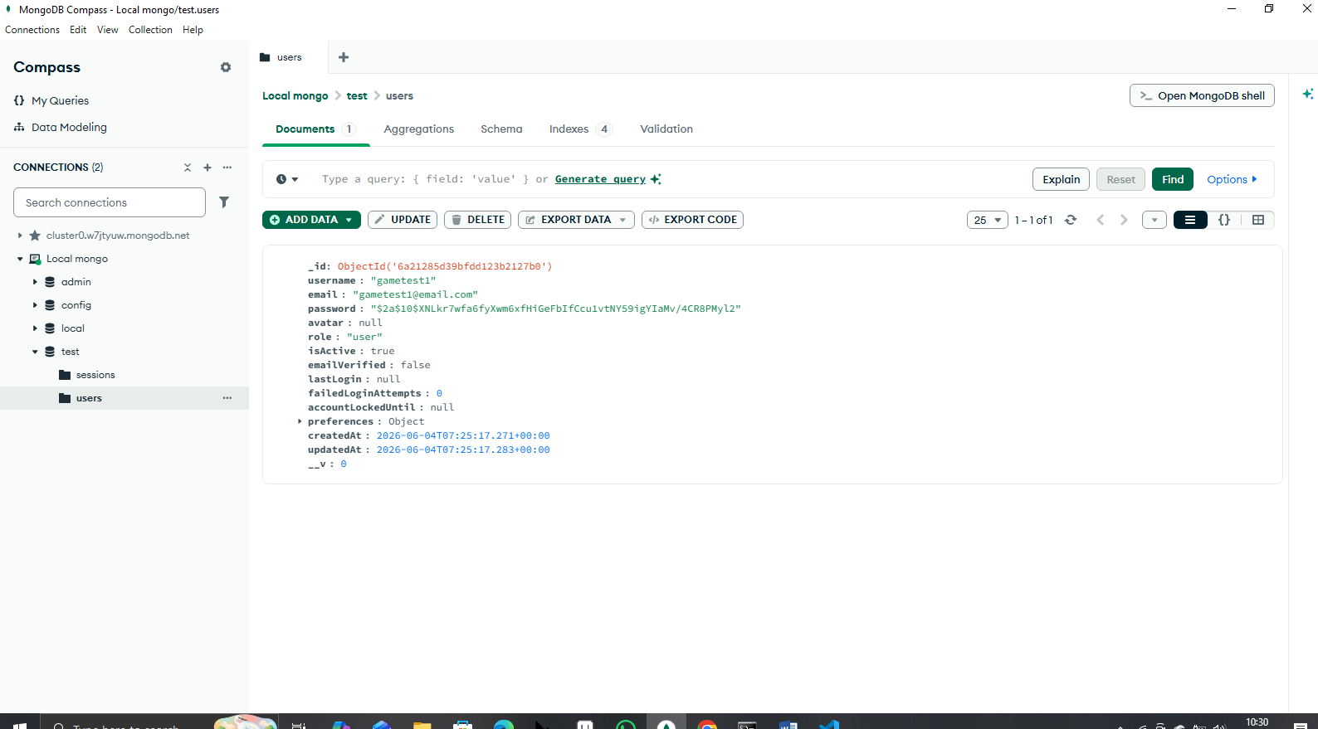
Figure 17: Screenshot of the Database

5.2 Table Creation and CRUD Operations.

Figure 18: User model created
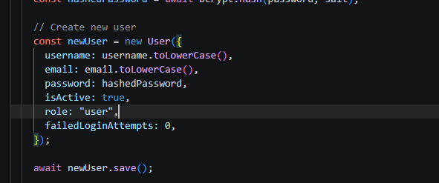
Figure 19: Code Snippet of the user creation
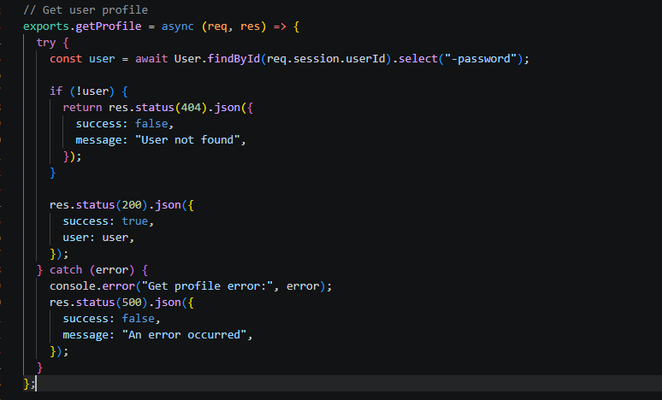
Figure 20: Update

